PATIENT INFORMATION AND DEMOGRAPHIC

PATIENT INTAKE FORM

Name: (Last) ____________________________________ (First) ________________________________ (Middle) ______________
Gender: _________ Date of Birth: _____________________ Social Security Number: _____________________________________
Student: Y/N Language: ________________ Marital Status: ______ Employer Name: ____________________________________
Home Address: ______________________________________________________________________________________________
City: ____________________________________________________ State: ____________ Zip Code: ______________________
Mailing Address: (if different) __________________________________________________________________________________
Home Phone: __________________________ Mobile: ___________________________ Work:____________________________
Email: ______________________________________________________________________________
Emergency Contact: _____________________________ Relationship:_________________ Phone: __________________________
Insurance Name: _____________________________________ Subscriber ID: ______________________________
Subscriber Name: _____________________________________ DOB: __________________
Work Comp: Adjustor Name______________________________ Phone #____________________ Case #____________________
How did you find out about us?
Physician Referral (name)__________________________ Family/Friend Google
Facebook Yelp Other: ________________________________

As a courtesy, appointment reminders are sent the business day before your next appointment.
I want a reminder call/ text.
I DO NOT want a reminder call/ text.

Thank you for trusting your physical therapy care to SB Physio. When you schedule an appointment with SB Physio, we set aside enough time to provide you with the highest quality of care. Should you need to cancel or reschedule an appointment, please contact our office as soon as possible, no later than 24 hours prior to your scheduled appointment. This gives us time to schedule other patients who may be waiting for an appointment. Please see our Appointment Cancellations/No Show Policy below:
CANCELLATION POLICY

- Any established patient who fails to attend or cancels/reschedules an appointment and has not contacted our office with at least 24 hours’ notice will be considered a “No Show” and charged a $50.00 fee.

- We reserve the right to withhold further treatment of any patient who has accrued 2 No Show charges until their account has been balanced.

- If a third No Show or cancellation/reschedule with no 24- hour notice should occur, the patient may be dismissed from SB Physio.

- Any new patient who fails to attend for their initial visit twice will not be rescheduled.

- The fee is charged to the patient, not the insurance company, and is due at the time of the patient’s next office visit.

- As a courtesy, when time allows, we make reminder calls for appointments. If you do not receive a reminder call or message, the above Policy will remain in effect.

We understand there may be times when an unforeseen emergency occurs and you may not be able to keep your scheduled appointment. If you should experience extenuating circumstances please contact our Office Manager. You may contact SB Physio 24 hours a day, 7 days a week, at the number below. If you are calling after regular business hours Monday through Friday, or a weekend, you may leave a message.
SB Physio (805) 682-2536
I have read and understand the Appointment Cancellation/ No Show Policy and agree to its terms.

Signature (Parent/Legal Guardian) Relationship to Patient

Patient Name Date

FINANCIAL POLICY: You are responsible for your bill. We bill your preferred billing method solely as a courtesy to you. If you change insurance coverage while undergoing treatment, it is your responsibility to notify the office of this change. In the event that your insurance company requests a refund of payments made to us, you may be responsible for the amount of money refunded to your insurance company. If formal collections procedures become necessary, you will be responsible for additional costs incurred. The attached benefits information is not all-inclusive. It is limited to coverage limitations, terms of your contract with your insurance, terms of any direct or indirect contract we hold with the payer, and your specific insurance plan’s interpretation of the medical necessity of the services provided. Please refer to your insurance plan’s applicable benefit agreements to determine any limitations or exclusions for your rehabilitation services.
FINANCIAL/OFFICE POLICY AND PRIVACY NOTICE

PLEASE CHOOSE YOUR PREFERRED BILLING METHOD:
Personal Insurance Plan
♦ I understand that SB Physio will bill the insurance company, but that it is ultimately my responsibility to know the extent of my insurance benefits. _____________ (please initial)
Self-pay
♦ I choose to self-pay at the cash rate. I further understand that no insurance company will be billed and that I cannot change from this option during my course of treatment. ____________ (please initial)
HIPPA AND NOTICE OF PRIVACY PRACTICES: I understand that SB Physio may use or disclose my personal health information (PHI) for the purposes of carrying out treatment, obtaining payment, evaluating the quality of services provided, and any administrative operations related to treatment or payment. I understand that I have the right to restrict how my PHI is used and disclosed for treatment, payment and administrative operations if I notify the practice. I also understand that SB Physio will consider requests for restrictions on a case by case basis, but does not have to agree to requests for restrictions. I hereby consent to the use and disclosure of my PHI for purposes as noted in SB Physio’s Notice of Privacy Practices, which is displayed in the reception area and a copy of which is available upon request. I understand that I retain the right to revoke this consent by notifying the practice in writing at any time. By signing this form, I am acknowledging receipt of the Notice of Privacy Practices for SB Physio. ____________ (please initial)
CONSENT FOR CARE & TREATMENT: Your Physical Therapist will complete an evaluation by examination and interview. Your individual treatment program will then be designed. A variety of treatment techniques may be used. I the undersigned do hereby agree and give my consent for SB Physio- A Physical Therapy Corp. to furnish physical therapy care and treatment considered necessary and proper in evaluating or treating my physical condition. ____________ (please initial)
ASSIGNMENT OF INSURANCE BENEFITS: I hereby authorize SB Physio- A Physical Therapy Corp to furnish information to insurance carriers concerning this treatment and I hereby assign all payment for services rendered.
CO-PAYMENTS: If applicable, co-payments are due at the time of service.
NON-SUFFICIENT FUNDS: Checks returned for Non-Sufficient Funds may be subject to a $25 processing fee.
I UNDERSTAND MY RESPONSIBILITY FOR THE PAYMENT OF MY ACCOUNT.

________________________________________________________ ___________________
PATIENT/GUARDIAN SIGNATURE DATE

________________________________________________________
PRINTED NAME
Name: Date: Gender: Male Female
MEDICAL SCREENING FORM

Date of Birth: Height: Weight:
Occupation: Currently working? Yes No Date of Injury: _______________
Please describe your current symptoms:

When did symptoms start?
How did symptoms start?

My symptoms are currently: Getting Better About the same Getting Worse
Please list any previous treatments for the condition we are seeing you for today:

Have you fallen in the past 12 months? Yes No
If so, how many times?
Have you had imaging studies done for this problem (x-rays, MRI, etc)? Yes No
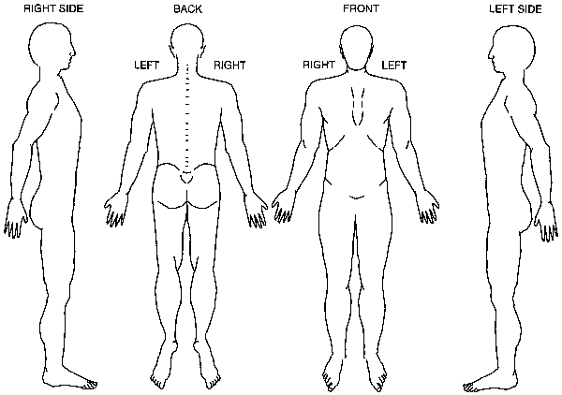
Please use these symbols to note symptoms location: ^^ Numbness ** Pins & Needles // Pain

Circle the number that represents your average level of pain over the past week:
No Pain 0 1 2 3 4 5 6 7 8 9 10 Worst Pain
Circle the number that best represents your worst level of pain over the past week:
No Pain 0 1 2 3 4 5 6 7 8 9 10 Worst Pain

Please list any allergies:

Please list any other current medical conditions:

Please provide a list of current medications:

